2FA with smartcard

- Access the migration link with your smartcard into the smartcard reader and opt for “sign in using smartcard”
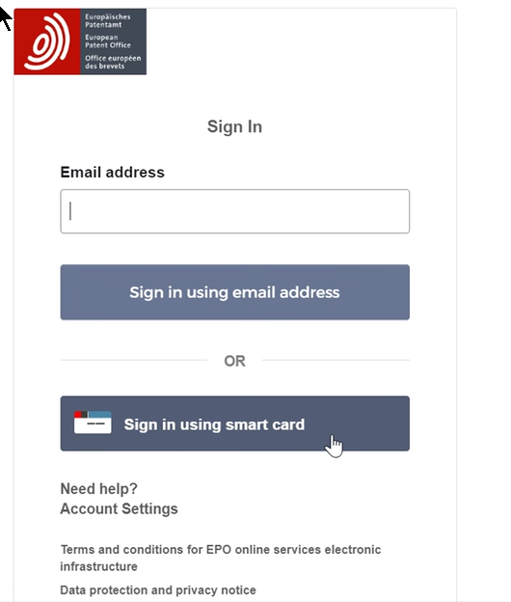

- Select your certificate
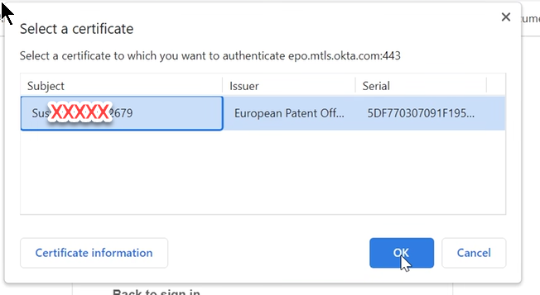

3. Enter the PIN in the dialog field

4. Create access to “account” with email address and confirm.
This email is the one you will use to sign in to the account.
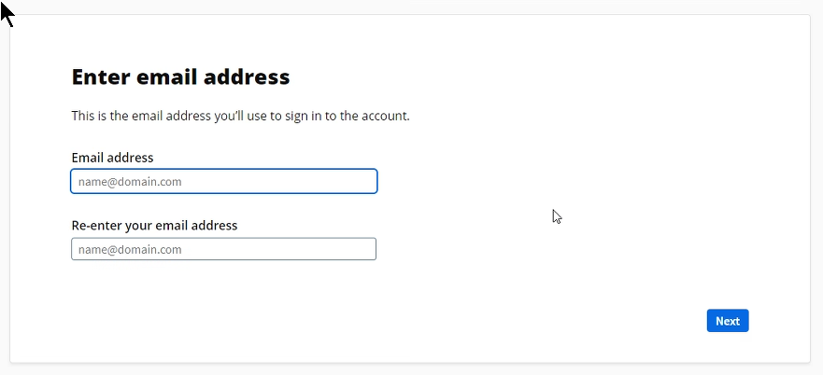

5. Create password.
This password is the one you will use to sign in to your account

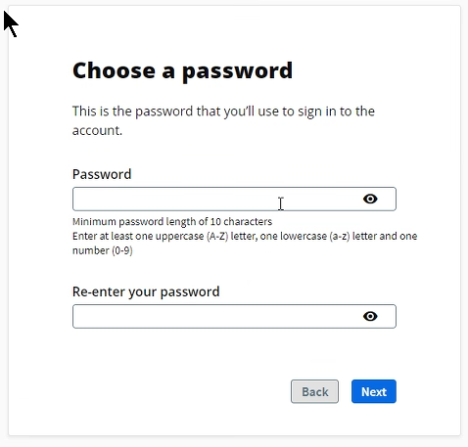

6. Choose one verification method i.e Code sent by text message clicking on “add”
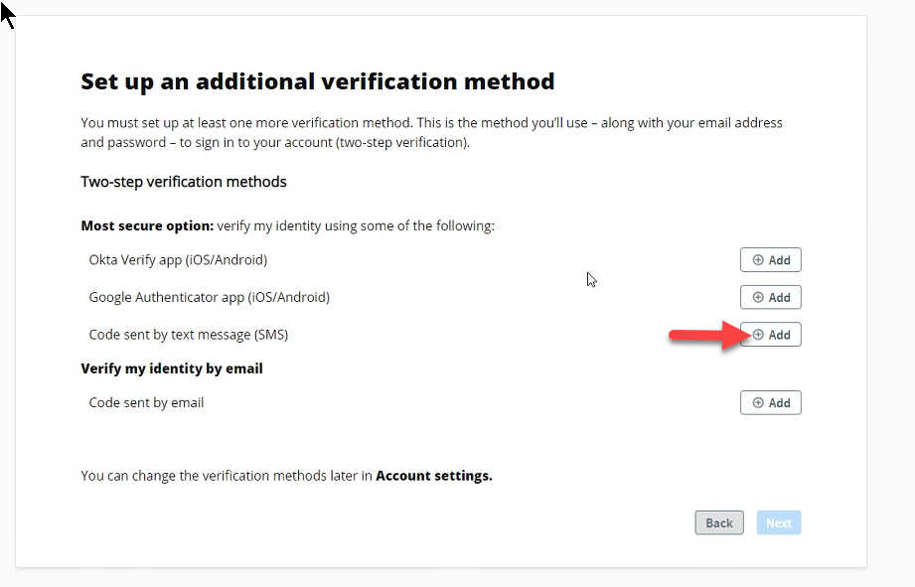

7. This will prompt you to enter your phone number with + and country code i.e Italy
+39
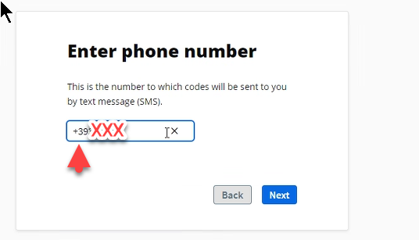

8. Enter the code number you receives via SMS and click next
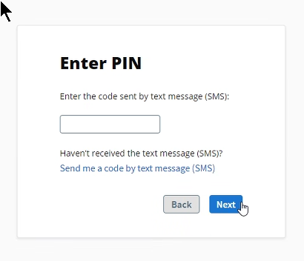

9. In order to activate the service click “back”
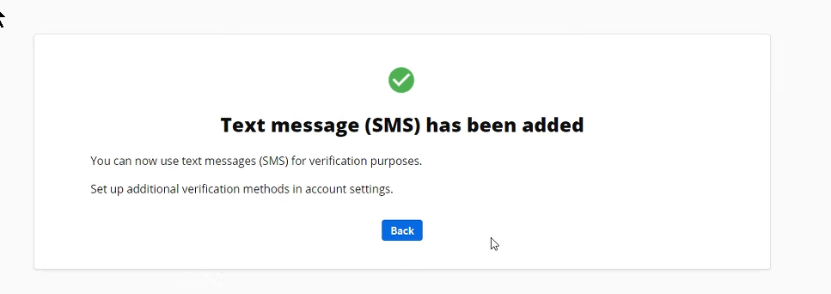

10. You will be prompted with the following screen where a green icon indicates that the service is on; click next
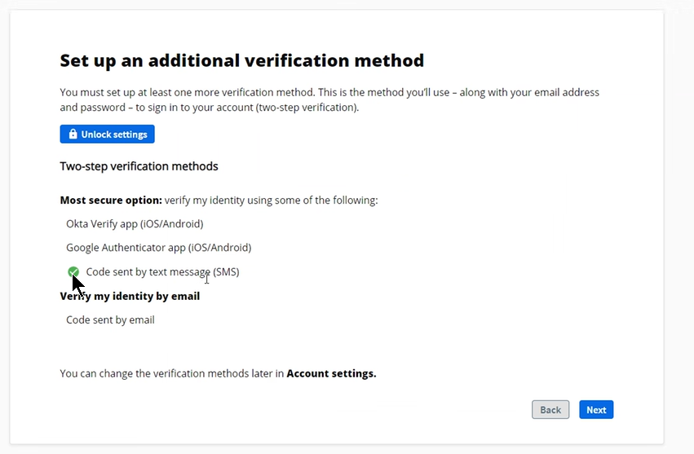

11. Tick the box to accept “Terms and conditions” and click on
Enable other verification methods
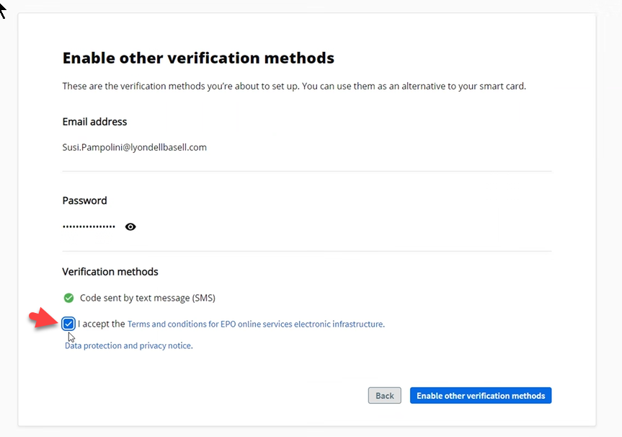
12. You are now able to log in via username and password in MyEPO from the EPO webpage immediately.
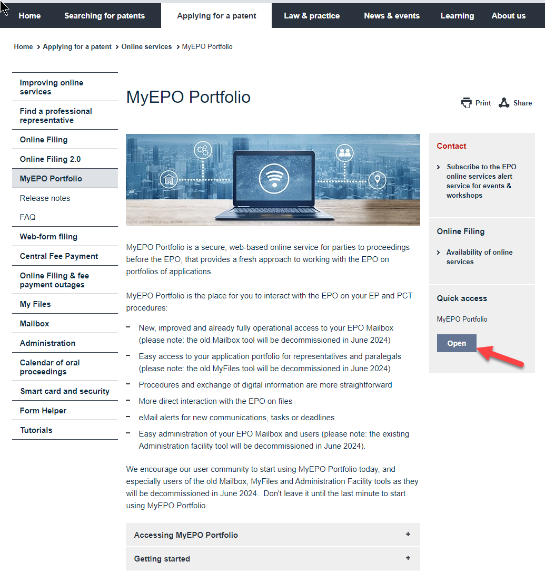

13. Insert email address:
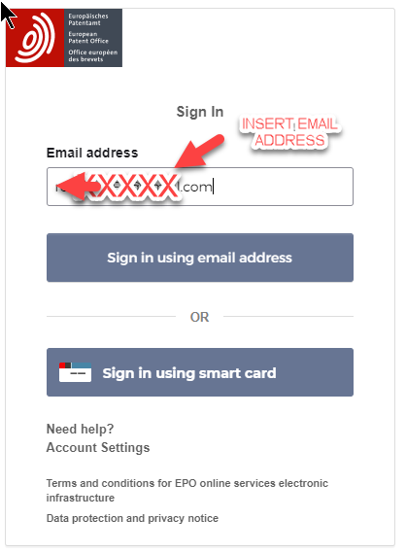

14. Insert password and click verify
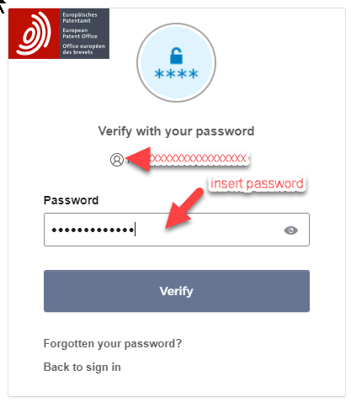

15. The screen with the phone number is prompted, click “receive a code via SMS”
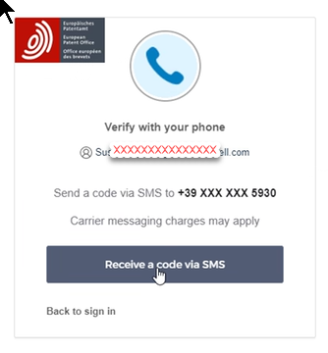

16. Insert code received via SMS and click verify.
You will see MyEPO platform.
